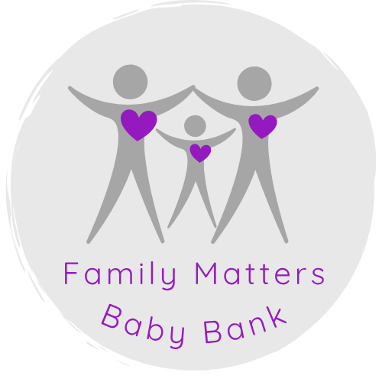

Please help us with our Baby Bank Alliance statistics!
From now on we will ask you for certain information of your family.
When visiting us, you can only collect items for your immediate family. If you are collecting for family members or friends, they need to come in to self-refer (you can use this service once a month) or get a professional to do that for you. (you can use this service every week) You cannot take any items for friends or other members of your family.
Thank you so much for your patience and understanding.

