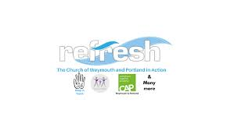


Family Matters Adult Clothing Referral Form

Client
Name

Postcode

Weymouth and Portland Resident YES / NO

Agency /Referrer Name

Reasons for Referral

Family Matters, 14 Cambridge Rd, Weymouth DT4 9TJ
family.matters.adultclothes@gmail.com

Refresh, Registered charity number: 1158394
The Church of Weymouth and Portland in Action.

